**CREATE AND CONFIGURE IBM SERVICES** **IOT WATSON PLATFORM**

|  |  |
| --- | --- |
| DATE | 17/11/2022 |
| TEAM ID | PNT2022TMID19339 |
| PROJECT NAME | SMART SOLUTION FOR RAILWAYS |

Step1: Log in your registered id

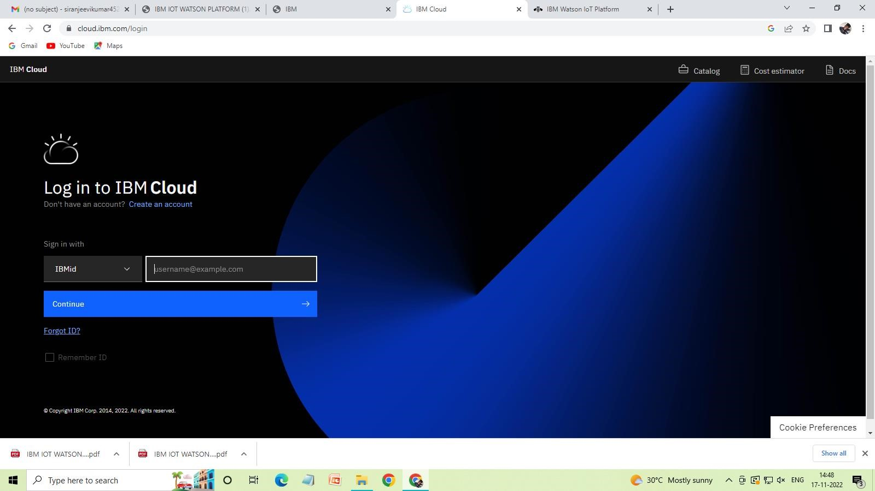

Step 2: Click Catalog where you find the services and internet of thing you can select and make location as Frankfurt

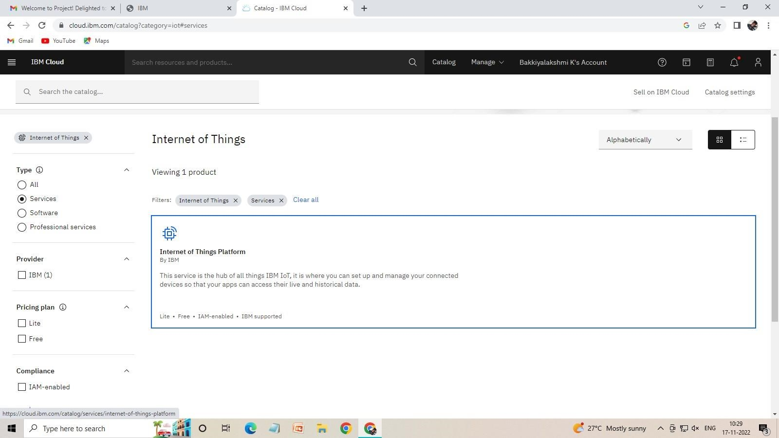

Step 3: click create and the launch tab get open, then click launch

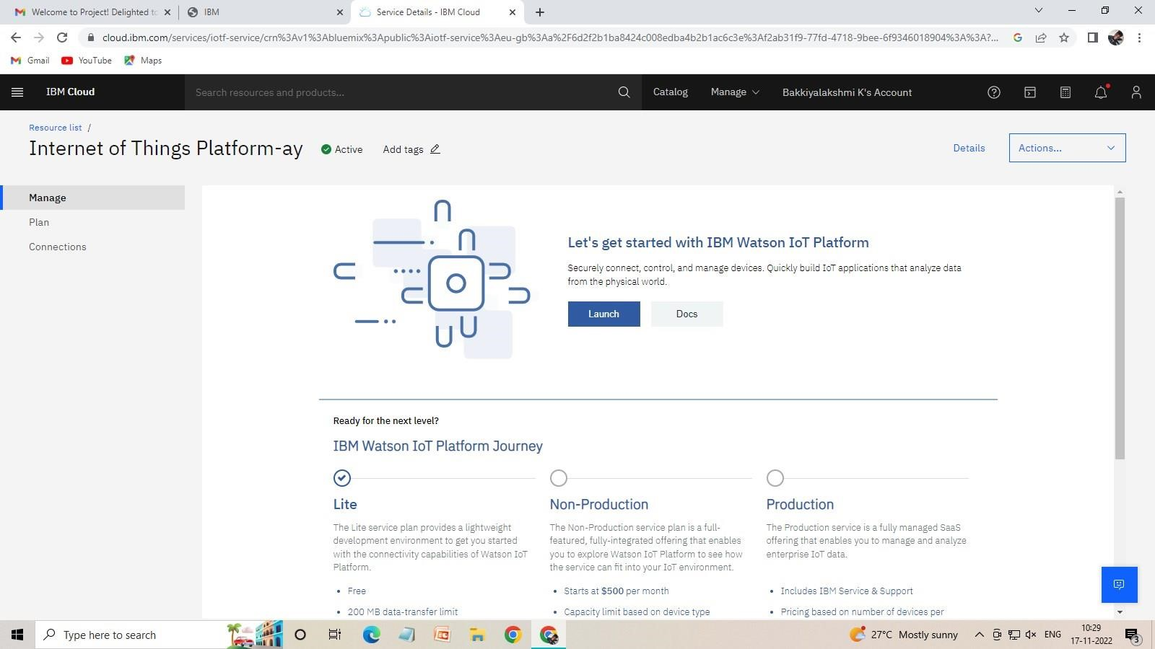

Step 4: It redirect you to IBM WATSON platform where you need to click sign in and login IBM.

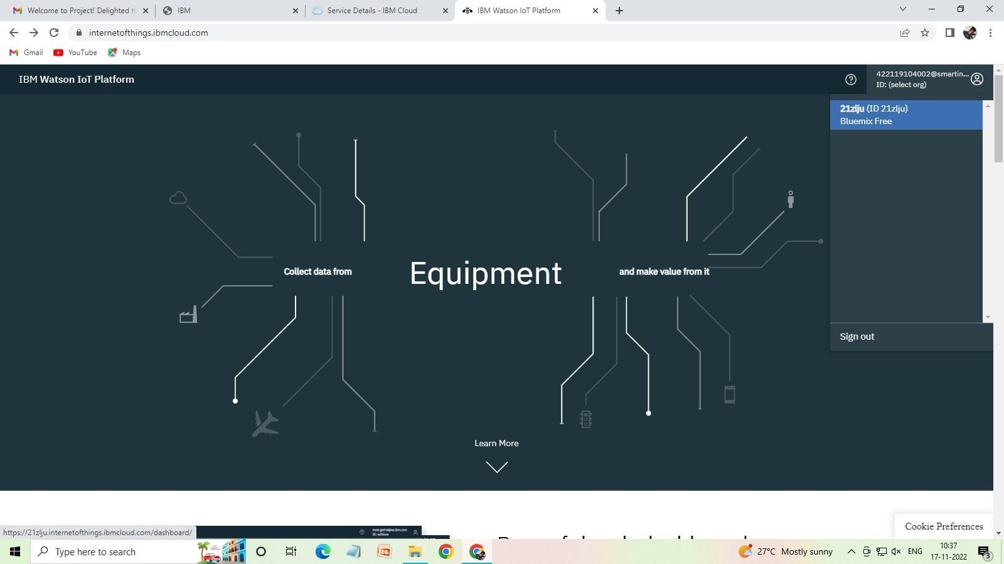

Step 5: where you find this tab which is used to add device, app, member, usage, security can be worked

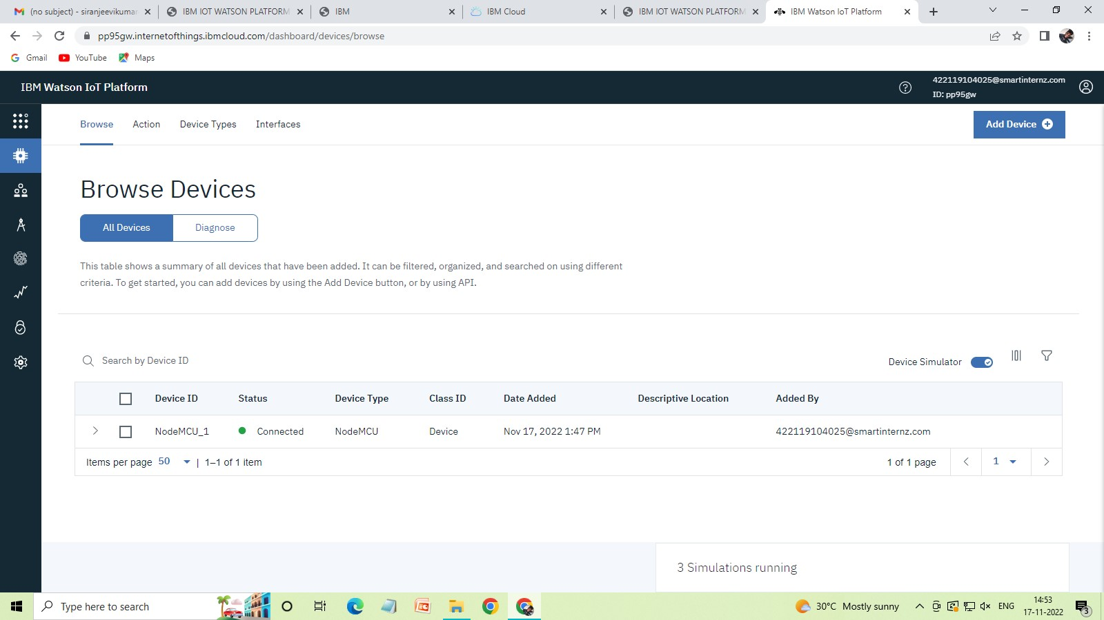

Step 6: check boards for risk and security overview card, it uses for graphical representation boards

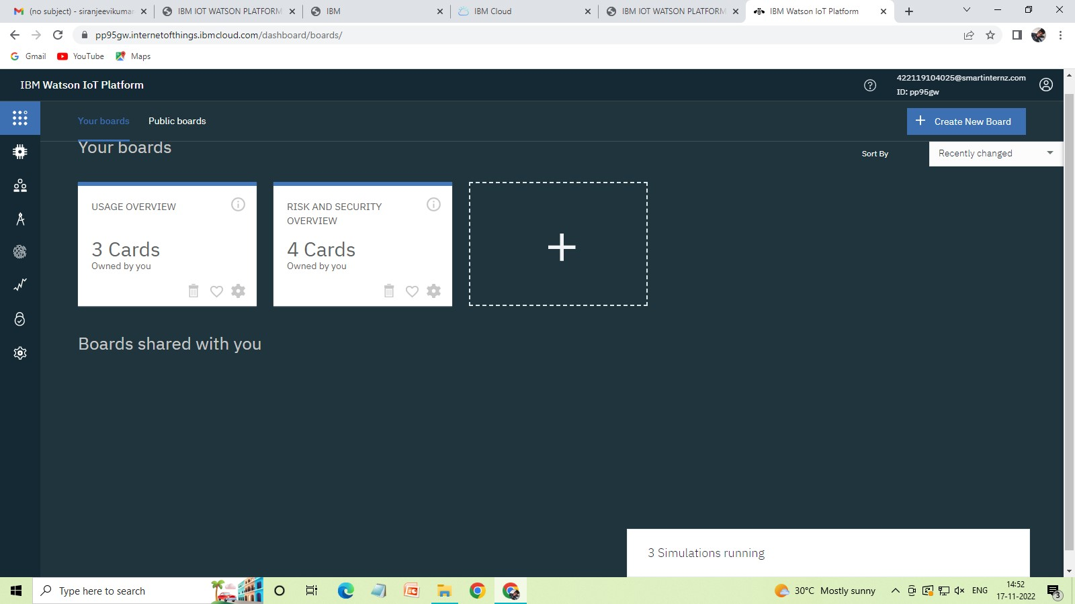

Step 7: after clicking create a new device / add device you can choose a device type and device id and complete the following information to create a device

